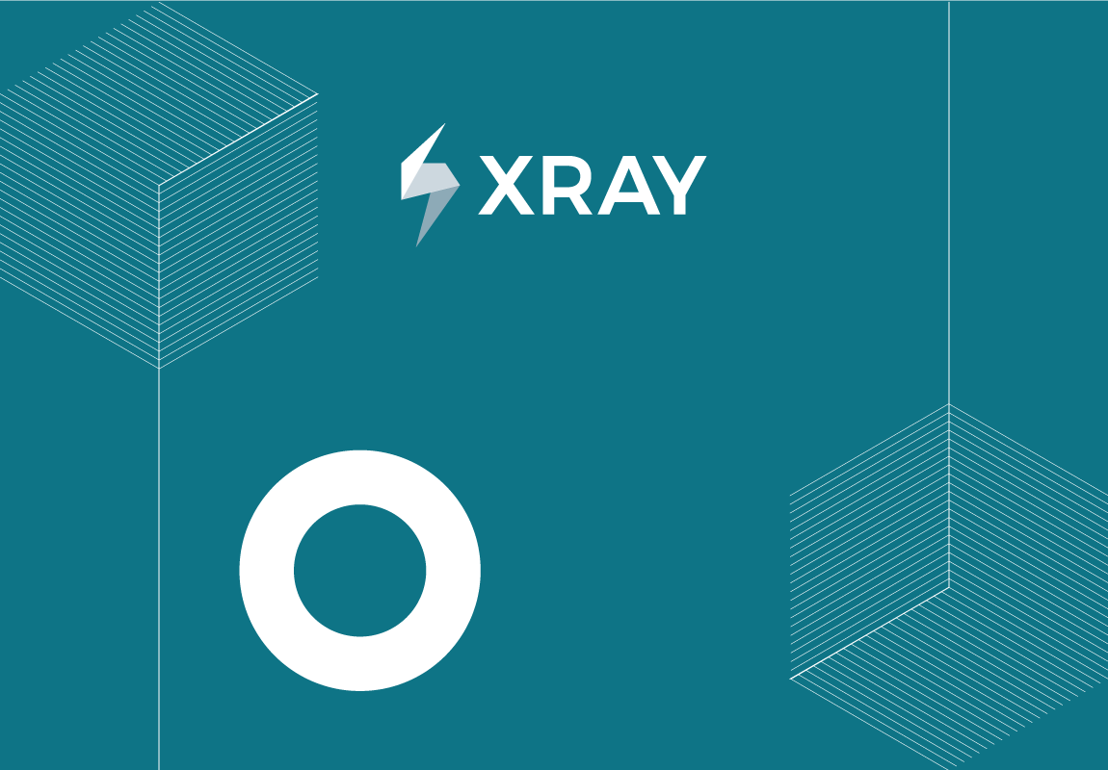

Prepared By: Michelle Dieudonne Yenyo

Document Date: 28/2/2025

 CONFIDENTIAL



**Requirement Traceability Matrix Report**

**Requirement Traceability Matrix**

|  |  |  |  |
| --- | --- | --- | --- |
| Requirement | Status | Linked Tests | Linked Tests Defects |
| MBMS-87659 - Self-Service: Pre-Need: Integration: Research to Determine if the UUID on CMP Packet is Being Duplicated on Multiple Packets | **UNCOVERED** |  |  |
| MBMS-87648 - Self-Service: Pre-Need: Integration: Action Items from Architecture Review | **UNCOVERED** |  |  |
| MBMS-87550 - Cont Self-Service: Pre-Need: Integration: Foundational Accessibility Testing | **UNCOVERED** |  |  |
| MBMS-87549 - Cont. Self-Service: Pre-Need: Integration: Advanced Accessibility Testing | **UNCOVERED** |  |  |
| MBMS-87406 - Self-Service: Pre-Need: Integration: Cont. URL research | **UNCOVERED** |  |  |
| MBMS-87325 - Self-Service: Pre-Need: Integration: URL research | **UNCOVERED** |  |  |
| MBMS-86820 - Self-Service: Pre-Need: Integration: Architecture Intent Preparation | **UNCOVERED** |  |  |
| MBMS-86444 - Self-Service: Pre-Need: Integration: Privacy, Security, Infrastructure Readiness Continued - P3 | **UNCOVERED** |  |  |
| MBMS-85936 - Self-Service: Medallions: Veteran Info Section: Screens 1-3 | **UNCOVERED** |  |  |
| MBMS-85245 - Self-Service: Pre-Need: Integration: Privacy, Security, Infrastructure Readiness Continued - P2 | **UNCOVERED** |  |  |
| MBMS-85215 - Self-Service: Pre-Need: Integration: Frontend/Backend Branches Update | **NOTRUN** |  |  |
| MBMS-84629 - Self-Service: Medallions: Review and Sign: Initial Shell of Digital Application | **OK** |  |  |
| MBMS-84614 - Self-Service: Medallions: Applicant Info Section: Signed In User: Screens 4-9 | **UNCOVERED** |  |  |
| MBMS-84612 - Self-Service: Medallions: Review and Sign: Initial Shell of Digital Application | **OK** |  |  |
| MBMS-83611 - Self-Service ART: Pre-Need: Address Validation - FY25Q2 | **OK** |  |  |
| MBMS-83404 - Self-Service ART: Pre-Need: Support and Maintenance FY25Q2 | **NOTRUN** |  |  |
| MBMS-83403 - Self-Service ART: Pre-Need: Integration to CaMEO Technical Enablement FY25Q2 | **UNCOVERED** |  |  |
| MBMS-82682 - Self-Service: Medallions: Applicant Info Section: Not Signed In User | **UNCOVERED** |  |  |
| MBMS-82681 - Self-Service: Medallions: Applicant Info Section: Signed In User: Screen 1 | **UNCOVERED** |  |  |
| MBMS-82277 - Self-Service: Medallions: Supporting documents Section | **UNCOVERED** |  |  |
| MBMS-82276 - Self-Service: Medallions: Introduction Screen | **UNCOVERED** |  |  |
| MBMS-82253 - Self-Service: PreNeed: Integration: Create Low Traffic Monitor for NCA from Endpoint | **UNCOVERED** |  |  |
| MBMS-82183 - Self Service: Preneed Integration Code Coverage (Address/MBMS-73710) | **UNCOVERED** |  |  |
| MBMS-80689 - Self Service: Form remediation for oversized pdf | **UNCOVERED** |  |  |
| MBMS-80121 - Self-Service: Medallions: Initial Shell of Digital Application | **OK** |  |  |
| MBMS-80106 - Self-Service: Medallions: Supporting documents Section | **UNCOVERED** |  |  |
| MBMS-80102 - Self-Service: Medallions: Veteran Info Section | **UNCOVERED** |  |  |
| MBMS-80101 - Self-Service: Medallions: Applicant Info Section | **UNCOVERED** |  |  |
| MBMS-80100 - Self-Service: Medallions: Introduction Screen | **UNCOVERED** |  |  |
| MBMS-80099 - Self-Service: Medallions: Initial Shell of Digital Application | **OK** |  |  |
| MBMS-80098 - Self Service: Preneed Integration Code Coverage (Utils) | **UNCOVERED** |  |  |
| MBMS-80097 - Self Service: Preneed Integration Code Coverage (Pages) | **UNCOVERED** |  |  |
| MBMS-80096 - Self Service: Preneed Integration Code Coverage (Config) | **UNCOVERED** |  |  |
| MBMS-80095 - Self Service: Preneed Integration Code Coverage (Components) | **UNCOVERED** |  |  |
| MBMS-78696 - Self-Service: Pre-Need: Complete Checklist/Research Silent Errors Maintenance | **UNCOVERED** |  |  |
| MBMS-78361 - Self-Service: PMC: Supporting files: Consistency Updates | **OK** |  |  |
| MBMS-77900 - Self-Service: Pre-Need: Supporting documents section is accepting PDFs larger than the maximum allowed | **OK** |  |  |
| MBMS-77352 - Self-Service: Pre-Need: Cont Research Silent Errors Maintenance | **UNCOVERED** |  |  |
| MBMS-77190 - Self-Service: Pre-Need: Research Silent Errors Maintenance | **UNCOVERED** |  |  |
| MBMS-76145 - Self-Service ART: Pre-Need: Integration to CaMEO Technical Enablement FY25Q1 | **NOTRUN** |  |  |
| MBMS-76143 - Self-Service ART: Pre-Need: Support and Maintenance FY25Q1 | **OK** |  |  |
| MBMS-75956 - Self-Service: Pre-Need: Integration: Ensure that branch of service is synced across VA.gov and CaMEO | **OK** |  |  |
| MBMS-74646 - Self-Service: Pre-Need: Integration: Privacy, Security, Infrastructure Readiness | **UNCOVERED** |  |  |
| MBMS-74645 - Self-Service: Pre-Need: Integration: Advanced Accessibility Testing | **UNCOVERED** |  |  |
| MBMS-74644 - Self-Service: Pre-Need: Integration: Foundational Accessibility Testing | **UNCOVERED** |  |  |
| MBMS-74643 - Self-Service: Pre-Need: Integration: Endpoint Monitoring | **UNCOVERED** |  |  |
| MBMS-74642 - Self-Service: Pre-Need: Integration: Unit Test Coverage | **UNCOVERED** |  |  |
| MBMS-74631 - Self-Service: Pre-Need: Integration: Traceability Reports | **UNCOVERED** |  |  |
| MBMS-74617 - Self-Service: Pre-Need: Integration: Test Plan Generation | **NOTRUN** |  |  |
| MBMS-73710 - Self-Service: Pre-Need: Integration: Service Periods: New Component Design | **OK** |  |  |
| MBMS-73524 - Self Service: Pre-Need: Update integration content document based on most recent changes | **UNCOVERED** |  |  |
| MBMS-73396 - Self-Service: Pre-Need: Service Periods: New Component Design | **OK** |  |  |
| MBMS-73196 - Self-Service: Pre-Need: Integration: Update Place of Birth Fields | **OK** |  |  |
| MBMS-73195 - Self-Service: Pre-Need: Integration: Update Place of Birth Fields | **OK** |  |  |
| MBMS-73192 - Self-Service: Pre-Need: Integration: Update "Prefer not to answer" functionality | **OK** |  |  |
| MBMS-73172 - End to End Testing | **OK** |  |  |
| MBMS-72637 - Self-Service: Pre Need: Research: Address Validation | **UNCOVERED** |  |  |
| MBMS-72601 - Self-Service: Pre-Need: trouble shooting step and maintenance item | **UNCOVERED** |  |  |
| MBMS-72511 - Self-Service: Pre-Need: Pre-Integration: Ensure that branch of service is synced across VA.gov and CaMEO | **OK** |  |  |
| MBMS-72496 - Self-Service: Pre-Need: Integration: Preparer Flow: Enhancements/Functionality | **OK** |  |  |
| MBMS-72495 - Self-Service: Pre-Need: Integration: Preparer Veteran Flow: Place of Birth Field Enhancements | **OK** |  |  |
| MBMS-72490 - Self-Service: Pre-Need Integration: va-memorable-date error padding issues | **UNCOVERED** |  |  |
| MBMS-72489 - Self-Service: Pre-Need Integration: va-memorable-date style issue when in error state | **UNCOVERED** |  |  |
| MBMS-72246 - 2nd Cont. Self-Service: Pre-Need: Research: Vets-api: Front end displaying of cemeteries (research) | **UNCOVERED** |  |  |
| MBMS-72146 - Cont. Self Service: Pre-Need: WF and Epic Generation: New Component: Service Period(s) | **UNCOVERED** |  |  |
| MBMS-72097 - Cont. Self-Service: Pre-Need: Research: Vets-api: Front end displaying of cemeteries (research) | **UNCOVERED** |  |  |
| MBMS-72032 - Self Service: Pre-Need: Update integration and Medallions prototype with multiple response component | **UNCOVERED** |  |  |
| MBMS-71996 - Self-Service: Pre-Need: Address Validation: Suggested Address Not Found | **OK** |  |  |
| MBMS-71979 - Self-Service: Pre-Need Integration: Prefacing 0 Submission Check | **UNCOVERED** |  |  |
| MBMS-71733 - Self-Service: Pre-Need: Invalid date format pdf stamper | **UNCOVERED** |  |  |
| MBMS-71539 - Self-Service: Pre-Need: Integration: Address Validation Functionality: Suggested Address Found | **OK** |  |  |
| MBMS-71527 - Self-Service: Pre-Need: Address Validation Functionality | **UNCOVERED** |  |  |
| MBMS-71364 - Update integration prototype with V3 components | **UNCOVERED** |  |  |
| MBMS-71304 - Self-Service: Pre-Need Integration: Duplicate Error on Memorable Date Validation | **UNCOVERED** |  |  |
| MBMS-71303 - Self Service: Pre-Need: WF and Epic Generation: New Component: Service Period(s) | **UNCOVERED** |  |  |
| MBMS-71199 - Self Service: Pre-Need: WF and Epic Generation: Address Validation Functionality | **UNCOVERED** |  |  |
| MBMS-70193 - Self-Service: Pre-Need: Pre-Integration: Mapping VA Form 40-1007 to Vets-API GoLive | **OK** |  |  |
| MBMS-69224 - Self Service: Pre-need: SSN masking is applied for all SSN fields | **OK** |  |  |
| MBMS-69222 - Self Service: Pre-need: ‘Prefer not to answer’ checkbox selections | **OK** |  |  |
| MBMS-69186 - Self-Service ART: Pre-Need: Support and Maintenance FY24Q4 | **OK** |  |  |
| MBMS-68637 - Self-Service: Pre-Need: Integration: Continued Military History Updates | **NOTRUN** |  |  |
| MBMS-68438 - Self-Service: Pre-Need: Integration: Sponsor Information: Sponsor's Place of Birth Field Enhancements | **OK** |  |  |
| MBMS-68435 - Self Service: Pre-Need Integration: Military History: Removing a service period sometimes removes the wrong entry | **NOTRUN** |  |  |
| MBMS-68371 - Self Service - Preneed connection to CMP (Frontend connection) | **OK** |  |  |
| MBMS-68369 - Self Service - Preneed connection to CMP (Update ERB file to match preneed-integrations JSON fixture) | **UNCOVERED** |  |  |
| MBMS-68368 - Self Service - Preneed connection to CMP (Form Model) | **NOTRUN** |  |  |
| MBMS-68367 - Self-Service: Pre-Need: Integration: Sponsor Information: Sponsor's Place of Birth Field Enhancements | **OK** |  |  |
| MBMS-68296 - Self-Service: 508 Compliance: Pre-Need Integration: Military History Screen: Highest rank attained error not appearing | **OK** |  |  |
| MBMS-67628 - Self-Service: Pre-Need: Integration: Mapping VA Form 40-1007 to Vets-API | **NOTRUN** |  |  |
| MBMS-66254 - Self-Service: Pre-Need: Integration: Supporting files: Encryption File Error Messaging Updates | **OK** |  |  |
| MBMS-66058 - 508 Compliance: Self-Service: Pre-Need: Supporting Files: Upload file modal | **UNCOVERED** |  |  |
| MBMS-65502 - Self-Service: Pre-Need: Research: Vets-api: Front end displaying of cemeteries (research) | **UNCOVERED** |  |  |
| MBMS-65126 - PROD Flag Removal - Update CMP Connection to Remove Dark Status for Go Live | **OK** |  |  |
| MBMS-65005 - Self-Service: Pre-Need Integration: Military History Section: Military Ranks align with Service Start & End Date | **OK** |  |  |
| MBMS-64196 - Self-Service: Pre-Need: Integration: Sponsor Information : "Are you the applicant's sponsor?" | **OK** |  |  |
| MBMS-64186 - Self-Service: Pre-Need: Update Integration Cypress Tests for Staging Review | **UNCOVERED** |  |  |
| MBMS-61959 - Pre-need Self Service: Contact information - Who is filling out this application spacing | **OK** |  |  |
| MBMS-58075 - Self-Service: Pre-Need: Integration: Introduce the ability to pre-fill preparer information from their VA profile | **OK** |  |  |
| MBMS-58072 - Self-Service: Pre-Need: Confirmation: Implement correct alignment for the ‘Your claim has been submitted’ sub header | **OK** |  |  |
| MBMS-55218 - Self-Service: Pre-Need: Integration: Supporting files Updates | **OK** |  |  |
| MBMS-55217 - Self-Service: Pre-Need: Integration: Supporting files Updates | **OK** |  |  |
| MBMS-53401 - Self-Service: Pre-Need: Integration: Confirmation Screen Updates | **OK** |  |  |
| MBMS-44677 - Self-Service: 508 Compliance: Pre-Need - "Add another" button on Review Page Cards | **UNCOVERED** |  |  |
| MBMS-43838 - Self-Service Pre-Need Review Page Cards Should Each Have an Edit Button | **OK** |  |  |
| MBMS-43495 - Self-Service: Pre-Need Integration: Confirmation Screen Updates | **OK** |  |  |
| MBMS-40366 - Self-Service PreNeed: Allow Veterans to enter their full address in forms #34987 | **OK** |  |  |
| MBMS-40278 - Self-Service: Pre-Need: Continue your application button appears after submitting an application issue | **OK** |  |  |

107 Requirements Exported